Skills, Monsters,

The Third Book

Adventure

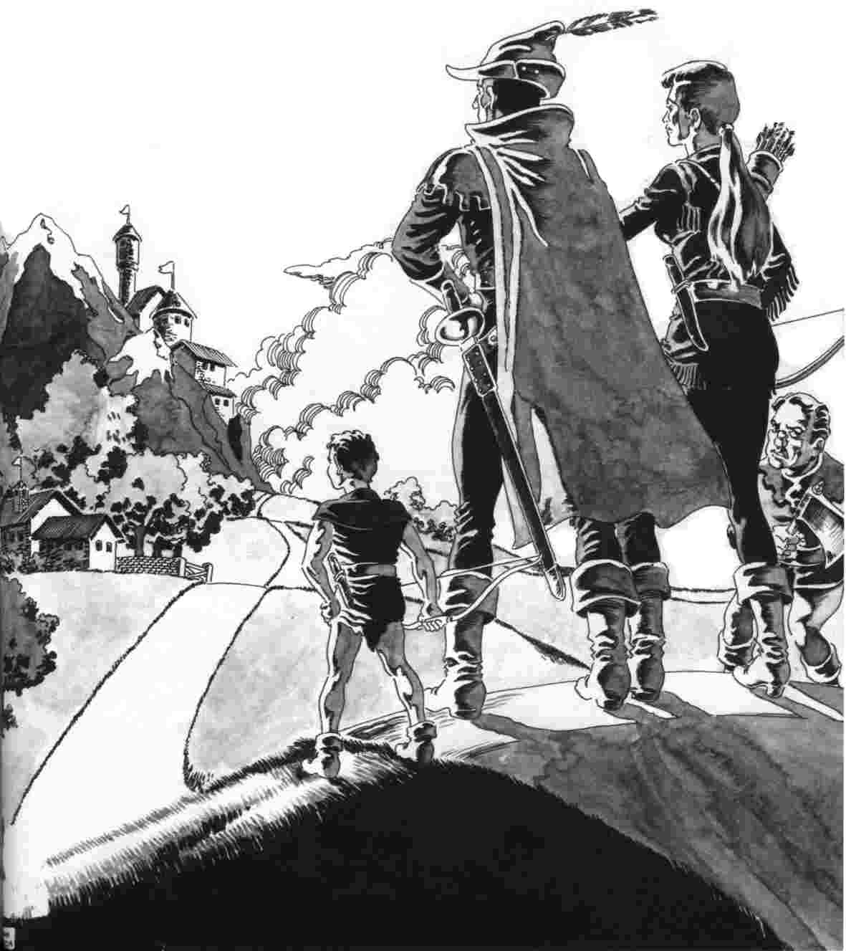

VII.
SKILLS
A character may acquire and refine skills during a campaign. He can hone his talents in a series of interrelated non-magical and quasi-magical abilities, which combine to form a single skill. A character's degree of talent is measured by his Rank in a skill. He begins with the simplest abilities at the lowest Ranks, and gains the more difficult ones as he progresses through the Ranks. His percentage chance of successfully performing tasks associated with a skill will increase as his Rank becomes higher. The skills presented here are only those likely to be used by a character during an adventure. The fruits of the labors of those using other, more plebeian, skills may be purchased. The gamesmaster will be guided in determining the price (in Silver Pennies) of the various goods produced by craftsmen by the Basic Goods Cost List (81.4). Weaponsmiths' products are valued on the Weapons Chart (20.3); Armorers'
DRAGONQUEST SECOND EDITION, PAGE 86
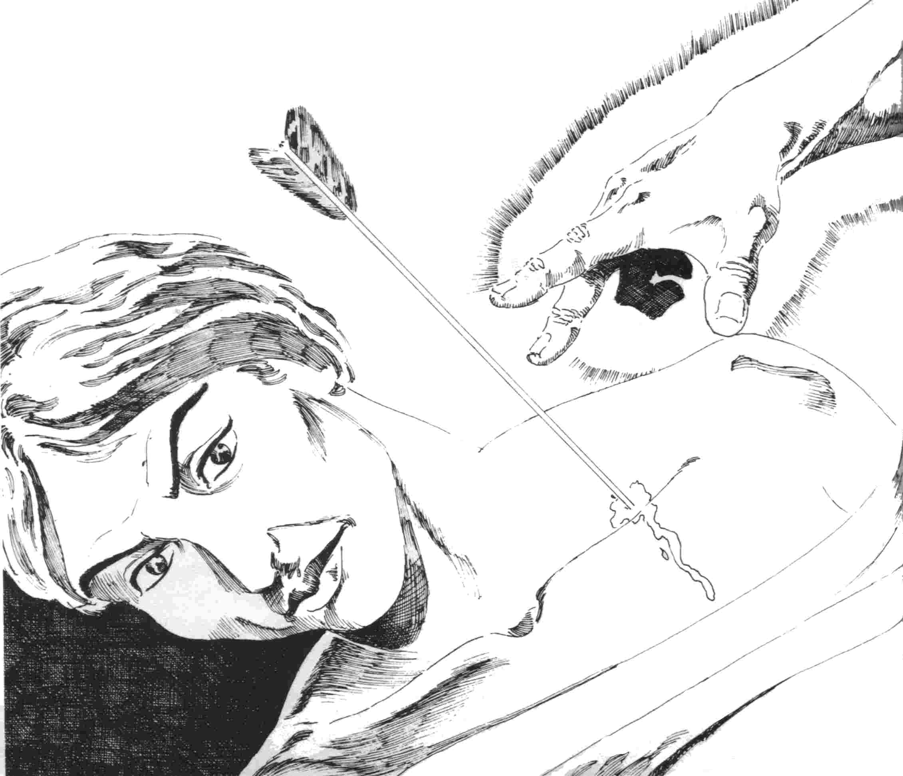

on the Armor and Shield Charts (18.1 and 17.5). The three factors which determine the price of finished goods are the quality of the material used, the man-hours spent in construction, and the estimated Rank of the craftsman (if one person produces the goods) or of the overseer (if the effort is a team project). However, if a character wishes to purchase a custom-made or rare item, then he will have to negotiate with the craftsman (represented by the gamesmaster), and may defray costs by providing some of the scarcer components himself. The barter system is acceptable when dealing in costly or rare items.
48. ACQUIRING AND
USING SKILLS
The rudiments of a skill are learned by dint of hard practice and diligent study. A character must spend a good deal of time and effort before he can use a skill at novice level (Rank 0). The character's ability with a skill can improve only if he continues to work with it during and between adventures.
[48.1] Any skill may be acquired at Rank 0 at a variable cost of Experience Points and 8 weeks of game time (see 78.1).

All eight weeks must fall within a period of six game months. Time spent on adventure may not count toward the necessary eight weeks. One skill may be acquired without the expenditure of time and at a minimal expen-diture in Experience Points (see 8.6).

[48.2] The method by which a character learns a skill affects the Experience Point cost to acquire that skill or to increase the character's Rank.
If the character is taught by someone of greater Rank in the skill, decrease any Ex-perience Point cost by 10%.
If the character learns from a book, verbal descriptions or practices with someone of equal or lesser Rank in the skill, any Experience Point cost is unmodified.
If the character practices with no useful outside assistance, any Experience Point cost is increased by 25%.
The availability of qualified teachers, and the fees they charge the character for their services, are left to the discretion of the GM.

[48.3] A character may attempt to employ a non-magical skill any number of times during a day.
The use of a skill does not, in and of itself, prevent a character from using the same or any other skill immediately afterwards. However, a character might suffer adverse fortune (e.g., lose Fatigue Points) while executing a skill, which would inhibit his ability to act.

[48.4] The use of a non-magical skill is rarely automatically successful.
A character usually has a chance of failure when using a non-magical skill. Unless the ability is described as an exception to this rule, the maximum chance to succeed with it is never greater than (90 + Rank)%. A character always fails if the roll is greater than the modified chance or 100 (regardless of rank).

[48.5] Very few of the abilities
associated with the various skills
are quasi-magical.
The following rules describe the only quasi-magical abilities to be found in the skills section: 50.7, 50.9, all of 52 and 55, 56.3 and 62.6.

[48.6] A character must practice
any skill he acquires or risk a
decrease in Rank.
A character must use one game day to fulfill the practice requirement once a month for one skill. If a character fails to practice a skill for one month, he may satisfy the practice requirement by the use of four game days during the following month; if he fails to practice for two months, eight game days will satisfy the requirement during the third month of the cycle. Days of practice during the second month may count towards the third month requirement.
If a character has not sufficiently practiced a skill by the third month, his Rank in that skill is decreased by one. If the skill is at Rank 0, he loses that skill.
Note: A character practices his skills of speaking, reading and writing in a language through conversation and correspondence; it should be assumed that he is able to do this independent of his other practice

49. SPECIAL SKILLS: SPOKEN AND WRITTEN LANGUAGES
Many languages and dialects are to be found in a typical DragonQuest world. The primary linguistic division is between species; the secondary one is cultural. The prevailing spoken language is the Common tongue, which is spoken by most sentients. Illiteracy is quite common, so there is no one universally recognized written language. Generally, while there may be spoken dialectic differences within a language group, the contemporary writings in that language will be virtually identical. Records which date from separate eras will, of course, employ different idioms and connotations of certain words, reflecting the ongoing change in
SKILLS, MONSTERS & ADVENTURES, PG 87

that language. Each species will have a distinct tongue, as will each national group of humans.
As he constructs his world, the GM will decide which languages are spoken by beings in the area in which the player characters will adventure. Most creatures with an IQ greater than 90 (which includes the majority of humanoids) speak the Common tongue, if not as a first language, then as a second. Common is known as the "trade tongue," and most interracial and international negotiations are conducted in that language. When a written record is necessary, each party usually obtains a copy in their own language. Thus, an interpreter will always be in demand.
Every beginning player character can speak Common (see 49.6). If the character is non-human, they will also speak their racial language or dialect. A human or shape-changer character can read and write in Common, a skill other non-human characters must acquire. When characters encounter a creature who does not (or will not) speak Common, they must either have learned that creature's native tongue, or assay sign language.

[49.1] The ability to speak a language and the ability to read and write in that language are separate skills.

[49.2] If a character's Rank in speaking a language is greater than their Rank in reading and writing that language, the character expends one-half the necessary Experience Points to acquire or improve the latter.
The reverse is also true.

[49.3] The ease with which a character can engage in conversation in a particular language is indicated by their Rank in it.
Rank | Ability
0 Has a grasp of pronunciation and inflections; able to speak a few words.
1 Develops a limited vocabulary, consisting of the most important words in the language (but see Rank 5).
2 Understands grammatical construction of language.
3 Capable of halting speech; understands pedestrian conversation.
4 Becomes conversant with current idioms.
5 Concepts peculiar to the language or alien to the character understood.
6 Moderate fluency: can make anything but difficult concepts clear in conversation.
7 Able to make sense of another dialect of the language after a decent amount of exposure to it.
8 Native fluency: can pass for same.
9 Commands enhanced vocabulary.
10 Able to understand another dialect of language with a minimum of study.
Note: If a character's vocal chords are not designed to reproduce the speech of another race, then the character will never be able to pass for a native without magical aid.

[49.4] A character's facility for reading or writing in a language is determined by their Rank in that skill.
Rank |  | Ability
0 | Knows the entire alphabet (for symbology); able to recognize key words or phrases.
1 | Acquires a basic vocabulary, consisting of the most important words (but see Rank 5).
2 | Understand grammatical construction of language.
3 | Can describe simple concepts in writing; understands most simple books.
4 | Becomes familiar with idioms.
5 | Concepts peculiar to the language or alien to the character understood.
6 | Moderately fluent writer: can draft correspondence and essays, retains some awkward phrasings.
7 | Able to make sense of another dialect of language after considerable study.
8 | Fully fluent writer: comfortable with the language.
9 | Commands enhanced vocabulary.
10 | Able to understand another dialect of language without much study; writer of scholarly tracts and able to understand meanings of ancient writings in language.

[49.5] The extent of a character's vocabulary is indicated by the highest Rank they have achieved in one of the language skills.
Rank | Words Known
0 | 50 (plus phrases)
1 | 250 to 500
2 | 600 to 750
3 | 800 to 1000
4 | l250 to 2500
5 | 3000 to 5000
6 | 10,000
7 | 20,000
8 | 25,000
9 | 40,000
10 | 50,000

[49.6] If a character begins with the ability to speak or read and write in a language, their Rank in that skill is presumed to be 8.
Thus every character speaks Common at Rank 8.

50. ALCHEMIST
Almost all natural chemicals can be combined into a variety of useful mixtures by expert hands. The potions which will be in most demand by characters will be those that affect the bodily functions of humanoids. The effects of these potions range from stimulation and depression of emotions to deadly poisons. In a sense, alchemy is a "poor man's magic"; it is more cost-efficient in affecting the actions of beings than the use of mana, albeit not as easily applied to the victim.
There are five main areas of study of alchemy. The first is that of chemical analysis, the ability to determine the effects of ingestion

or application of a given liquid substance. The others are: standard chemicals, medicines and antidotes. poisons (including venom) and potions. The creation of a potion requires the aid of an Adept.
As a character gains experience in the field of alchemy, they will increase the efficacy of the mixtures they produce. The character will also decrease the cost of goods (to themself).
An alchemist must know how to read and write in one language if they wish to advance beyond Rank 0.

[50.1] An alchemist gains the ability to analyze chemicals at Rank 0.
An alchemist may identify a liquid by its type (e.g., medicine, poison). If the liquid is not a common one, the alchemist must spend (110 - [10 x Rank] ) minutes using the proper equipment to analyze the liquid's type.
If a liquid to be analyzed is particularly well-known to the alchemist (such as water or wine), they will recognize it almost immediately.
If an alchemist wishes to determine exactly what a not readily identifiable substance is, the GM rolls D100. If the roll is equal to or less than the alchemist's Perception plus (8 x Rank), the alchemist is told the common name of the substance in question (e.g., hemlock, quicksilver). If the roll is greater than the success percentage, the GM either informs the alchemist that they are not sure or gives an incorrect answer. The greater the roll, the more likely the GM is to give false information.

[50.2] An alchemist can injure himself while working with dangerous chemicals.
Whenever an alchemist uses or analyzes a liquid with potential injurious effects, there is a chance that some of the substance will come in contact with their person. The GM incorporates the accident chance into any other alchemy-related percentile roll; should there not be one, the alchemist rolls D100. The chance of accident is (30 - [(2 x Rank) + (Manual Dexterity)] %. If the roll is within the span of numbers for accident, the alchemist suffers from the chemical. A roll of 100 always causes an accident.
Example: An alchemist character with a Manual Dexterity of 17 and of Rank 3 would have a 7% chance of failure. Any roll from 94 to 100 will cause the alchemist to have an accident
The GM will determine the exact effects upon the unfortunate character. The minimum damage will be from formaldehyde-type chemicals, which will cause about 1 Damage Point and causes blisters. The maximum damage from a non-magical liquid will be from something on the order of non-dilute hydrochloric acid, which will cause about 12 Damage Points per pulse, and possibly permanent bone and tissue damage. The effects of certain chemicals are described in the following Cases. Unless either the GM or the player have a fair knowledge of chemistry, the
DRAGONQUEST SECOND EDITION, PAGE 88

alchemist should restrict himself to common liquids.
If the alchemist is dabbling with dangerous chemicals without using the proper equipment (see 50.3), double the chance of accident. If an alchemist is working in their lab, they may prevent damage due to chemicals after the first round (unless they are incapacitated during the first round) by pouring the appropriate counteragent upon the affected area.
If a combination of chemicals forms a gas or a solid, the character's Agility value is substituted for their Manual Dexterity when rolling for accident.

[50.3] An alchemist will be able to better perform their skill when using the proper equipment or when working in a laboratory.
It costs 500 Silver Pennies per year to purchase basic equipment. This includes acid-resistant (not proof) flasks, gloves, pipettes, etc. A character may not mix chemicals to specified measurements unless they use proper equipment.
It costs 2500 Silver Pennies to construct a lab, and 1000 Silver Pennies per year to maintain it. An alchemist can only manufacture medicines, antidotes, poisons, or potions or distill venom in a lab. A laboratory may be rented at a cost of 15 Silver Pennies per day.
The chance of an alchemist correctly analyzing a chemical (see 50.1) is increased by 10 when they perform the analysis in a laboratory.
The GM and an alchemist player should scale costs and effects of improved alchemical support material to the above rules.

[50.4] An alchemist must purchase the components necessary to manufacture each of their products.
A medicine costs (150 - [10 x Rank) Silver Pennies. An antidote costs (250 - [15 x Rank] ) Silver Pennies. The costs for poisons and potions are given with their rules (50.8 and 50.9). All costs given are for one creation attempt; if that attempt fails, new ingredients must be purchased.
The cost for a standard chemical will range from 1 Silver Penny for a quart of flammable oil to 2000 Silver Pennies for a fluid ounce of non-dilute hydrochloric acid. The GM should scale the costs of other chemicals appropriately.

[50.5] An alchemist can mix standard chemicals beginning at Rank 3, and may add one additional ability to their repertoire at Ranks 5, 7 and 9.
An alchemist chooses their additional ability from the following: medicines and antidotes, poisons (including venom) and potions.

[50.6] The ability to mix standard chemicals allows the alchemist to produce mixtures which can prove useful on expeditions.

An alchemist may produce well-known chemical combinations (e.g., oil and vinegar, water and anything) at any Rank. The standard chemicals ability allows the alchemist to perform most distillations and extractions, and mix the simplest of compounds.
For example, an alchemist can produce Greek Fire and methane with the standard chemicals ability. The components for 12 ounces of Greek Fire (enough to fill a grenado) cost 600 Silver Pennies. Enough methane to fill a grenado, can be manufactured at a cost of 300 Silver Pennies. If a creature is directly hit by a grenado filled with Greek Fire, that creature will suffer D10+7 Damage Points per Pulse until the flames are extinguished (the virtue of Greek Fire as a weapon is that it sticks to the target). A partial hit will cause D10-3 Damage Points per Pulse; if a shield is interposed between target and grenado, the shield catches fire, though the intended target suffers no more than 2 Damage Points. A methane grenado creates a ball of fire in the hex in which it detonates and the adjacent six hexes. Any creature in one of these hexes will suffer D10-3 Damage Points, but will be able to avoid further damage by exiting the fire hexes (methane is not a persistent inflammable).
Whenever an alchemist wishes to manufacture standard chemicals, they must spend D10 + 7 hours in a laboratory and pay For the components. The quantity mixed does not affect the time required, but an alchemist is limited to the manufacture of one end product during a given laboratory session.
An alchemist can produce standard chem-icals for the use of local businessmen (e.g., embalming: fluid for the undertaker), and earn between 50 and 75 Silver Pennies per full week of labor. Alternately, they may produce chemicals which are likely to be put to illegal uses (e.g., a corrosive for iron) or manufacture addictives (e.g., cocaine, heroin). The alchemist must discover an outlet to sell such chemicals, and the return on the goods is up to the GM's discretion.

[50.7] Medicines and antidotes are used to cure a being suffering from either disease, fever or poison.
An alchemist may manufacture three types of medicine: bactericide (remedy for disease), antipyretic (remedy for fever) and salve (remedy for skin inflammation). A bactericide or antipyretic must be ingested, while one dose of salve can cover up to two square feet of skin.
Whenever a being uses a medicine to counteract an affliction from which they are suffering, the GM rolls percentile dice. If the roll is equal to or less than ([8 x Alchemist's Rank] + [User's Endurance] ), the user is completely cured. If the roll is above the success percentage, the user subtracts 10 from their next dice-roll to see if they naturally recovers from their affliction (see 116). The failure of one medicine to work has no effect upon any subsequent medicines used by a being.
When an alchemist manufactures an antidote, they must specify the type of poison they are negating. Natural poisons are classified

by the source from which they stem. Thus, a snake antidote will cure all poison from snakes, and so on. Synthetic poisons (those manu-factured by alchemists) are cured by an antidote from an alchemist of equal or higher Rank than the alchemist who created the poison. When a being ingests the proper antidote, the poison in their system will no longer affect them.
[50.8] Poisons cause damage when introduced into the blood stream of a being.
Poisons come from two sources: those which occur in nature (venom from animals and plants) and those which are created in a laboratory (synthetic poisons). An alchemist may distill venom and synthesize poisons.
A venom is distilled from either the poison sacs of a poisonous animal (the most common being a snake), or from certain plants. An alchemist may distill D10-1 doses of poison from poison sacs. The amount they may distill from plants depends on the type of plant (GM's discretion). An alchemist requires (11 - Rank) hours to distill one dose of venom from either source. The cost of a poison plant or sac is [750 + (150 x Average Damage per Pulse)] Silver Pennies, and there is no cost for the distillation process.
Venom come in two forms: Nerve Agents and Blood Agents. Nerve Agents work quickly (doing damage every Pulse) while Blood Agents (such as arsenic) work over a long period of time, inflicting damage like Infections (see 116). The damage a being will suffer from a dose of Nerve Agent venom is equal to the damage it would suffer from the venom of the source animal or plant.
An alchemist may also manufacture synthetic poisons (both venom and paralysants) in their laboratory. A synthetic venom will do [D10 + Alchemist's Rank) -5] damage points per Pulse and costs [1000 - (75 x Rank)] Silver Pennies to manufacture. If a synthetic paralysant (see 116) is used to affect a being, the formula used for the Willpower Check of the victim is [(4 x Willpower) + 20 - (5 x Alchemist's Rank)] . A synthetic paralysant costs [750 - (60 x Rank)] Silver Pennies to manufacture. An alchemist can produce up to three doses of synthetic poison per day.
[50.9] Potions are created by an alchemist with the aid of either an Adept or a Healer.
Potions are designed to create a specific effect when imbibed by a being. They are manufactured in one-use doses and the entire dose must be swallowed for the effect.
Magical potions are treated by the concerted efforts of an Adept and the alchemist (who may be one in the same person). Any spell or talent which the Adept knows and which is designed to affect only the Adept or some facet of their own person may be imbued into a potion. It takes two whole days of continuous combined effort to create the potion. It is successfully created if at the end of the time the player roll is less than [(10 x Alchemist's Rank) + (Adept's Rank with the spell or talent)]. A roll above this indicates the potion is useless and the
SKILLS, MONSTERS & ADVENTURES, PG 89

process must be repeated with new ingredients, etc. The effect of a successful potion for the imbiber is as if the Adept had already made a successful Cast Check and the spell had taken effect. The workings of magical potions are immediate. The cost to manufacture a magical potion is equal to [(Experience Multiple of spell or talent x 20) - (Alchemist's Rank x 10)] .
An alchernist and a healer working together may create a healing potion (again, they may be the same person). The potions possible and their Base Value are listed in 311.9. The time required to produce the potion is the same as a magical one, and the equation to see if the process was successful is [(10 x Alchemist's Rank) + (3 x Healer's Rank)] . If successfully created, the potion will act on the imbiber as if a healer of the creator's Rank was attempting to heal them must still be attempted). The cost to manufacture a healing potion is [(Base Value) - (50 x Alchemist's Rank)] Silver Pennies.

51. ASSASSIN
Assassin is not a skill which should be carelessly chosen, as the skill is not looked upon with great favor by members of society (at least until they need one). Assassins will vary in philosophy and methods; they may be cold-hearted but not necessarily evil. The GM must allow assassins to practice their art as they wish, and this may result in solo adventures.

[51.1] An assassin must be able to use the sap or the garrote at a minimum of Rank 1 before advancing past Rank 2.

[51.2] An assassin increases his chance of causing a Grievous Injury as his Rank increases.
If the assassin is attacking in a surprise situation, his chance of causing a Grievous Injury is increased by 2% per Rank (see 504.2). A surprise situation is one in which combat has yet to be joined, and the victim is not expecting an attack.
If an assassin attacks a victim through a rear hexside during combat, his chance of causing a Grievous Injury is increased by 1% for every Rank.
If an assassin attacks a victim through a front hexside during combat, his chance of causing a Grievous Injury is increased by 1% for every three Ranks (round down).
An assassin does not gain the above bonuses when engaging in Ranged Combat.

[51.3] An assassin may gain information from a victim through torture.
The assassin must torture his victim for a period equal to ([Victim's Willpower] /[Assassin's Rank]) hours to try to gain an important secret. The assassin's chance of forcing the victim to reveal the secret is ([10 x Assassin's Rank] - [4 x Victim's Willpower])%. If the GM's roll on percentile dice is equal to or less than the success percentage, the assassin gains the exact information he requires.
If the assassin fails to gain the desired information, he may try another torture attempt. A victim can withstand a number of torture

attempts equal to one-fifth his Endurance (round down) before he dies.
If the information an assassin seeks is not of great importance to the victim, the GM should decrease the time required to gain it and increase the assassin's success chance appro-priately.

[51.4] An assassin is trained to improve his memory.
Whenever an assassin character wishes to recall the details of a place or routine he has surveyed. the GM rolls percentile dice. If the roll is equal to or less than ([5 x Perception] + [2 x Rank] ), the assassin has a perfect memory of the place or routine. If the roll is greater than the assassin's success percentage, the GM should inveigle more and more erroneous information into his description as the roll approaches 100.
The GM may decrease the success percentage for difficult feats of memory.

[51.5] An assassin is able to buy poisons, distilled venom and acids at cost (i.e., no mark-up) from an alchemist.

[51.6] An assassin causes his target increased damage when attacking through a rear hexside in Melee Combat.
Increase the damage caused by a blow from an assassin by 1 for every Rank when he strikes his target through a rear hex in Melee Combat.

[51.7] An assassin increases his chance of knocking out (see 108.5) his target with a sap by 2 for each Rank he has achieved in the skill.

[51.8] An assassin increases his chance of performing any action involving stealth (see 507.3) by 2 per Rank he has achieved with the ability.

[51.9] An assassin must pay (500 + [100 x Rank] ) Silver Pennies per year for "hush money," accouterments, and implements of destruction.
The GM and the player should negotiate prices for more sophisticated assassination equipment, and fees for information and the hire of henchmen.

52. ASTROLOGER
The celestial bodies have a definite, if not entirely understood, effect upon the lives of the inhabitants of a DragonQuest world. These Great Powers seem to impose predestination upon all but the strong-willed, and determine the aspect of each being. The Sun, the Moon(s), and the Planets regularly cause perturbations in the flow of mana; the mighty Stars affect a world across the vast reaches of space by their positions relative to it. The study of the purpose and method of the Powers is the science of astrology.
An astrologer's main talent is a limited ability to predict and shape the future. An astrologer will be able to make clear, general assertions, but will only be able to give obscure clues when asked for specific details.
An astrologer must be able to read and write in one language at Rank 8 if he wishes to

advance beyond Rank 0.

[52.1] An astrologer may only try once to answer a particular question or to forecast the outcome of an event.
Once an astrologer has made a reading (i.e., a determination about the future), he may not seek to change or influence the reading through his art. Other astrologers who attempt to read the same future will receive the same information that the first astrologer did. A second astrologer may, however, receive some clarification about the first's reading.

[52.2] The results of a reading will affect the pertinent course of events.
The GM is expected to modify the outcome of an adventure or happening in his world to conform with a determination made by an astrologer player characters or by an astrologer at the behest of the player characters. The determination does not preclude the characters' actions from affecting the outcome of the adventure or event: to the contrary, the GM must interpret the reading dice-rolls engendered by the characters' actions accordingly.
A prophecy can not be avoided by the affected character(s) changing his plans. The doom (which may be good) will follow him to the undertaking he substitutes for that which was predicted. However, if a character asks a specific question (sees 52.5) predicated upon a given action, the prophecy will not come to pass unless and until that action is taken.

[52.3] An astrologer's Rank determines how many beings he can directly affect with a single prediction.
A being is directly affected by an astrologer's art when the GM modifies the result of an action taken by the being due to a prophecy.
An astrologer can directly affect up to (5 + [10 x Rank] ) beings with a single prophecy. If an astrologer attempts a prediction which would directly affect more beings than his Rank allows, he receives no answer.

[52.4] An astrologer may make (and possibly modify) a general prediction during a reading.
When an astrologer wishes to make a general prediction about a particular venture or being, his player (or the GM, should the astrologer be a non-player character) actually uses a divinatory technique at his disposal. Such a technique could be reading the tarot, casting the I Ching, or any mutually agreed upon method.
The result of the divination becomes the astrologer's prediction. If the astrologer does not wish to make the prediction, he may immediately attempt to change it. The GM rolls percentile dice, and if the roll is less than or equal to ([5 x Willpower] + [4 x Rank] - 30), the astrologer makes a second divination (which may not be changed). If the roll is greater than the success percentage, the astrologer is stuck with his first prediction.

[52.5] An astrologer may seek an
answer for up to a number of
DRAGONQUEST SECOND EDITION, PAGE 90

specific questions per month equal to
his Rank.
When a being poses a specific question to an astrologer willing to attempt an answer, the GM rolls percentile dice. If the roll is equal to or less than ([6 x Astrologer's Rank] + [4 x Astrologer's Perception]), the astrologer is able to give a correct answer. If the roll is greater than the success percentage, he mutters meaningless gibberish.
All answers given to specific questions must be, at the very least, obscure. The GM may respond with cryptic poetry, much like the Oracle at Delphi, or may choose to have the astrologer supply a riddle (though the Player of the astrologer does not know the answer himself).

[52.6] An astrologer may not make a general prediction or ask a specific question concerning only himself.
One must consult another astrologer in these weighty matters.

[52.7] An astrologer can determine the aspect of a being after observing him.
After an astrologer has spent (60 - [5 x Astrologer's Rank] ) consecutive minutes observing a being, the GM informs the astrologer of the being's aspect (see 45).

[52.8] An astrologer expends Fatigue points when practicing his art.

Action | Fatigue Points Expended
Make general prediction |  | 10
Try to change general prediction |  | 10
Try to answer specific question |  | 17
Determine being's aspect |  | 5

[52.9] An Astrologer must spend (250 + [200 x Rank] ) Silver Pennies per year for astrolabes, oculars, reference works, and the like.
An astrologer who does not meet his expenses operates as if he were two Ranks less proficient. If his Rank is reduced to a negative number, he may not practice astrology.

53. BEAST MASTER
A loyal animal or monster is likely to serve its master far better than adventuring comrades ever will. A beast master is one who trains these creatures to obedience. He takes a wild animal and, from an adversary relationship, develops a rapport with it. He trains young animals from birth, until they heed his every command. A beast master will, in almost all cases, become very fond of animals. He will defend them against wanton cruelty and slaughter, and will treat his personal charges as family.
A beast master will encounter three kinds of animals: the easily domesticated (such as the horse), the naturally wild (such as the pegasus) and an intelligent or rebellious creature (such as the unicorn). The latter can never be steadfastly loyal to the beast master; such creatures always have at least a subconscious desire to escape. A

beast master can be a slaver if he specializes in training humanoids.

[53.1] The value of a beast master's Willpower must be at least 15.

[53.2] A beast master may only train animals for his own personal use until he achieves Rank 5. He may domesticate animals at any Rank.
A Beast Master will normally. use his skill to train or domesticate animals for his own use. Animals that spend their lives with a Beast Master and are trained by him will be loyal to their master and serve and protect him as much as possible. If necessary, an animal can be trained to temporarily serve another master (if one week of mutual training is undergone), but the animal will always obey the original master before any new one.
If a beast master's Rank is 5 or greater, he may train animal for other people. The being who is acquiring the trained creature must spend (12 - [Beast Master's Rank]) weeks before it will accept him as new master, during which the beast master must be present at least one day per week. The creature will heed the beast master's commands before those of its new owner for as many years as the beast master's Rank at the time the creature's ownership is transferred.
A beast master of any Rank may domesticate, rather than train, animals. Such animals can be commanded by any other person, but will tend to wander off or revert to their wild state if not supervised, tied up, or stabled. Pay especial attention to this rule: horses and dogs, the most common domestic animals, are governed by it.

[53.3] A beast master acquires the ability to train one type of animal and/or monster at Ranks 0, 5 and 10.
A beast master may acquire the ability to train additional types of creatures after he has achieved Rank 10 by the expenditure of 2500 Experience Points per type.
A type consists of all creatures listed within one rules section in the Monsters section (e.g., avians). A beast master may choose, instead, all creatures subsumed under a single animal family (e.g., felines).

[53.4] A beast master must spend (12 - Rank) months to train an animal or monster, or a like number of weeks to domesticate one.

If the creature  to be trained is... | Multiply the time  required by...
Easily domesticated |  | 0.5
Naturally wild |  | 1.0
Intelligent or rebellious |  | 3.0
Raised by beast master from adolescence |  | 0.5
Domesticated by another beast master |  | 1.0
Caught in wilderness |  | 1.5
The unmodified number of months required is multiplied by all applicable mod-

ifiers. The time to train a monster or animal is always dependent on the beast master's Rank when he begins the process. Any increases in Rank during the training or domestication period have no effect on the time required.

[53.5] A trained animal or monster must make a loyalty check whenever it recognizes that its master is endangering it, or whenever its master commands an action that runs counter to its instincts.
Whenever a loyalty check is required, the GM rolls percentile dice. He multiplies the beast master's Willpower by two, and adds four times his Rank: if the creature is intelligent or rebellious, six times his rank if the creature is naturally wild, and eight times his Rank if the creature is easily domesticated (if the owner is not a beast master, use his Willpower value and the Rank of the beast master when he trained the creature). If the roll is less than or equal to this success percentage, the trained creature will do as his master commands. If the roll is greater than the success percentage, the creature's reactions will range from balking to fleeing to turning on his master, as the roll increases (GM's discretion).

[53.6] A domesticated creature must make a loyalty check if the circumstances described in Case 53.5 arise.
The GM rolls D100. If the resulting number is less than or equal to ([Master's Willpower] + [Beast Master's Rank] ), the domesticated creature will perform the action. If the roll is greater than the success percentage, but less than or equal to two times that percentage, the creature will balk. If the roll is greater than two times the success percentage, but less than three times that percentage, the creature will take flight. If the roll is greater than three times the success percentage, the creature will turn on its master.
A roll of 100 always indicates that a domesticated creature turns on its master. A roll of 96 through 99 indicates that the creature takes flight if the success percentage is 47 or greater.

[53.7] A beast master who intimidates his creatures adds one to his Rank when calculating training or domestication time, but the GM adds 10 to any loyalty check dice-roll for one of his creatures.

[53.8] A beast master may train or domesticate as many creatures as his Rank at one time. All creatures being trained or domesticated concurrently must be of the same type.

[53.9] A beast master must pay 150 Silver Pennies a year for equipment, and must pay 100 Silver Pennies per creature trained and 25 Silver Pennies per creature domesticated during the year.
He may halve the cost for upkeep of creatures if he builds a stable. A horse-sized stable costs (500 + [150 x Stalls] ) Silver
SKILLS, MONSTERS & ADVENTURES, PG 91

Pennies to construct, and costs (10 x Stalls) Silver Pennies for repairs after the first year.

54. COURTESAN
Courtesanship is a social skill designed expressly to satisfy the needs of lonely or status conscious people. A master courtesan will be an accomplished musician, able to play at least one woodwind or string instrument. The master will also be able to sing, recite and compose stories and legends, perform mime, act out skits and dance. The consummate courtier is also the master of proper dress, and attractive appearance and is able to simulate a great range of emotions.
The abilities attendant to this skill are usable by such a character in situations not covered by the following rules, as are those of the troubadour skill (q.v.). The GM should improvise and allow a courtesan character to use his skill in appropriate instances. If, far instance, the party is at the mercy of a homely witch of indeterminate age, a male courtesan should be able to charm her and at least win his companions' lives if he plays it right.
A courtier is a male courtesan.

[54.1] A courtesan must generate a value for his Physical Beauty Characteristic (see 43.5).
A courtesan character must pay an additional Experience Point increment of 10% to increase his Rank in the skill when:
1. His Manual Dexterity is less than 12;
2. His Agility is less than 15;
3. His Physical Beauty is less than 15; or
4. He is death-aspected.
A courtesan character decreases the Ex-perience Point cost to increase his Rank by an increment of 10% when:
1. His Agility is greater than 22;
2. His Physical Beauty is greater than 20; or
3. He is life-aspected.
All modifiers are cumulative.

[54.2] A courtesan acquires one ability per Rank.
The character begins with one of the following abilities at Rank 0. All acquired abilities can be performed skillfully.
- Play a woodwind instrument (e.g., flute)
- Play a string instrument (e.g., mandolin, lute, etc.)
- Sing
- Recite stories and legends
- Compose stories and legends
- Perform mime
- Act out skits
- Tell jokes
- Dance
- Dress well (e.g., formally)
- Dress seductively
- Appear attractive (by other culture's standards)
- Simulate wide range of emotions
- Imitate accents
A courtesan may gain additional abilities after achieving Rank 10 by the expenditure of 500 Experience Points per ability.

[54.3] A courtesan may attempt to seduce a being with whom the courtesan is sexually compatible.
The courtesan must arrange a meeting with his intended paramour, either alone or with persons who will not interfere while the courtesan practices his wiles. The GM rolls percentile dice: the courtesan's base chance of success is equal to the courtesan's ([Physical Beauty] + [10 x Rank] ). The GM then modifies the success chance, dependent on the feelings and condition of the seductee.
If the roll is equal to or less than the success percentage, the seductee is infatuated with the courtesan and will retire with the seducer to a more private place. If the roll is greater than the success percentage, the outcome will depend on how great the roll is. A roll close to the success percentage calls for anything from "the body is willing but the spirit needs more convincing" to polite refusal, while a high roll can result in anything from mild embarrassment to the courtesan to violent consequences.
Player characters are not bound by the result when a courtesan uses his skill on them.

[54.4] A courtesan's fee for services is dependent upon Rank and gender.
A courtesan will receive (25+ [Rank squared] ) Silver Pennies for a night's work. A courtesan will receive (25 +- (Rank + 1) squared] ) Silver Pennies for the same job. The distaff side will do better at this profession in a male-dominated society. The pay rates are reversed in a matriarchy.
A courtesan is expected to charge a lower per diem if hired for consecutive evenings.

[54.5] A courtesan's social position has peculiar advantages and disadvantages.
A master courtesan is equally welcome at a royal ball and at the lowest dive in town. At the same time, a courtesan can be prevented from practicing his skill or imprisoned if the local authorities are so inclined. A courtesan should keep in mind that it helps to provide services at a discount or for free and to bribe the right people to ensure freedom of action.

[54.6] A courtesan must pay (250 +
[350 x Rank] ) Silver Pennies per year
for finery and the props of the trade.
A courtesan who does not spend the above amount operates as if he were two Ranks less proficient. If the Rank of a courtesan is reduced to a negative number, the use of the skill is temporarily lost.
The above amount does not include extraordinary aids, such as love philtres, but does include perfumes and other frippery.

55. HEALER
The life span of one who lives in a fantasy world is considerably longer than that of his medieval counterpart. The disparity in age can be attributed to the presence of healers where mana exists. These partially empathic beings can cure all the physical ills which beset a

character during adventure. Healers do not generally make good fighters, since active engagement in combat is usually contrary to the principles of their profession.
A healer will charge whatever his client can afford for his lower Ranked abilities. The charge for a miracle (the performance of an ability Rank 8 or greater) will normally exceed 2000 Silver Pennies.

[55.1] The abilities which can be used and the Fatigue Points expended when a healer practices his art depend upon his Rank.
A healer gains one or more abilities at each Rank he achieves, according to the following schedule:
Rank | Ability(ies)
0 | Empathy
1 | Cure Infection. Disease, Headaches, Fever
2 | Soothe Pain, Prolong Life
3 | Heal Wounds, Transfer Fatigue
4 | Neutralize Poison, Graft Skin
5 | Repair Muscle, Preserve Dead
6 | Repair Bones
7 | Repair Tissues and Organs
8 | Resurrect the Dead
9 | Regenerate Limbs and Joints
10 | Regenerate Trunk, Head and Vital Organs
A healer must expend as many Fatigue Points as the Rank at which he acquires an ability he uses (exception: see 55.2, paragraph 2). Example: The regeneration of limbs (a Rank 9 ability) will cost the healer 9 Fatigue Points.
A healer may use only his empathy ability if he is handless. A healer may use any of his abilities (with the exception of resurrection) upon himself.

[55.2] A healer must "lay hands" (place his hands) on a being on whom he is to use any of his abilities but empathy. When he does so, he can automatically detect the surface emotions of the being. he is healing.
A being's surface emotions are those which currently occupy their conscious mind. The GM informs the healer of the general feelings of the being with which he has empathy. Example: A healer lays hands on a comrade who has suffered a Grievous Injury. The GM informs the healer that his comrade feels great pain. If the healer lays hands on an assassin who is feigning injury to lull any suspicion the healer may have, the GM will inform the healer of the assassin's murderous intent just before he announces the result of the assassin's attack.
A healer may also choose the ability of non-tactile empathy (though this has its disadvantages; see below). A healer with such empathy may attempt to detect the surface emotions of a being no more than (2 x Rank) feet away from him at a cost of 1 Fatigue Point. The healer's success percentage is equal to his ([Perception] + 10 x Rank] ) if the other being consents to empathic communication. Subtract
DRAGONQUEST SECOND EDITION, PAGE 92

twice the being's Willpower if he Actively Resists (see 31.2) the detection of his surface emotions.
If a healer chooses the non-tactile empathy ability, subtract his Rank from his Base Chance to strike in Close Combat, and subtract one-half his Rank in Melee Combat (Example: A healer of Rank 8 would have 8% subtracted from his Base Chance in Close Combat and 4% subtracted in Melee Combat). If a healer only has empathy when laying on hands, subtract one-half his Rank from his Base Chance in Close Combat, and one-fifth in Melee Combat. Round fractions down in all cases.

[55.3] A healer cures fevers and diseases, neutralizes poisons and grafts skin in much the same manner that medicines and antidotes do (see 50.7).
When a healer attempts to cure a being of an affliction (i.e., fever, disease, or skin problem), his success percentage is ([15 x Healer's Rank] + [Patient's Endurance] ). The GM rolls percentile dice: if the roll is less than or equal to the success percentage, the patient is cured. If the roll is greater than the success percentage, the patient subtracts 10 from his next dice-roll to see if he naturally recovers from his affliction (see 24 and 85.2).
A healer must spend (30 - [2 x Rank] ) minutes to implement any of the abilities covered in this rule.
A healer automatically neutralizes the effects of a natural venom. A healer may automatically neutralize the effects of a synthetic poison created by an alchemist of equal or lesser Rank. His success percentage to neutralize a synthetic poison produced by an alchemist of greater Rank than he is equal to (50 - [5 x Difference in Rank] )%.
A healer does not cure any bodily damage (e.g., Endurance Point loss, broken bones) previous to his laying on hands on the patient with this particular ability (but see 55.8).

[55.4] A healer may soothe pain and prolong life.
When a healer uses his soothe pain ability, he numbs his patient's nervous system so that it will not transmit pain sensations to his brain. The ability also has a soporific effect upon the patient, so that he will not inadvertently injure himself while unable to distinguish hurtful actions. The GM may, at his discretion, permit the healer to use this ability as if he had fed or injected his patient with a local or general anesthetic, tranquilizer, etc. The effects of the soothe pain ability last for the healer's (Rank squared) hours.
When a healer uses the prolong life ability, add D10 x ([Healer's Rank] +[Patient's Endurance] ) days to the life of his patient. A patient's life may not be prolonged to over three times his natural life. A being with a prolonged life has a reduced chance of resurrection (see 55.7).
A healer must spend (60 - [5 x Rank] ) seconds to implement the first ability, and a like number of minutes to implement the second.

[55.5] A healer can cure Endurance Points and transfer Fatigue Points.
When a healer uses the cure wounds (i.e., Endurance Points) ability, the patient is cured of D10 + (Rank - 5) Damage Points.
When a healer uses the transfer fatigue (points) ability, his patient gains one Fatigue Point for each Fatigue Point the healer expends (above the fatigue cost to use the ability).
A being may never have more Fatigue or Endurance Points than the value of the relevant characteristic. Excess points cured by the healer have no effect upon the patient.
A healer may not use the cure Endurance Points or transfer Fatigue Points abilities while on the Tactical display (i.e., not while in combat). It requires (11-Rank) minutes each time the healer implements either of these abilities.
[55.6] A healer may repair torn, damaged, or broken muscles, bones, tissues and organs.
At least one-half of a muscle, bone, or organ to be repaired must remain in the patient's body if the healer is to use one of these abilities. Tissue may be grown from existing material in or on the patient's body. The healer must spend (50 - [3 x Rank] ) hours laying hands on the patient and the body part will be whole again.
Generally, these abilities will be used to repair the effects of Grievous Injuries.
A healer can act as a cosmetic surgeon. First, he sedates his patient with the soothe pain ability. He then slices and reshapes the skin, muscles, and bones which are deemed unsightly, and makes them whole with the appropriate repair ability. Unless the healer has gained the regeneration abilities (see 55.8), it is best that he work with a healer partner.
[55.7] A healer can preserve the body of a dead being in the hopes of having him resurrected.
A healer may attempt the resurrection of a being who is no more than (10 x Healer's Rank) hours dead. However, a healer can suspend the time limit on resurrection by preserving the dead body of a being. Each time a healer uses the preserve dead ability, the body will not "age" for a number of days equal to the healer's Rank. A healer must lay hands on a dead body for (60 - [5 x Rank] ) minutes to preserve it.
A healer must have a body part at least the size of a torso to attempt the resurrection of a being. A healer will not succeed if he attempts the resurrection of a living being from a severed body part (there is only one life-force). If a body is completely destroyed (perhaps burned), which prevents the resurrection of the being, that thing may become a revenant.
When a healer attempts to use the resurrect the dead ability, the base success percentage is equal to ([8 x Healer's Rank] )+[Patient's Endurance] ). The base percentage- is modified as follows:
1. Add 5% if the healer is life-aspected;
2. Add 5% if the patient is life-aspected;
3. Subtract 5% if the healer is death-aspected;
4. Subtract 5% if the patient is death-aspected;

- Subtract 1% for each year (or fraction thereof) the patient's life has been prolonged;
- Subtract 1% for each day of regeneration (see 55.8) it would normally require to make the patient's body whole;
- Subtract l0% if the patient's body is whole but suffered Damage Points equal to or greater than twice his Endurance when he died (the patient's slayer may carve up the body to bring this provision into effect); and
- Subtract 10% for each unsuccessful resurrection attempt since patient died.
The minimum success percentage for resurrection is equal to the Rank of the healer, regardless of the total modifiers.
If the roll in D100 is equal to or less than the success percentage, the patient is resurrected with his body whole. His Endurance is decreased by one, though all of his other values remain as before he died. If the roll is greater than the success percentage, the, patient is not resurrected and his Endurance is decreased by one. His body is preserved for one full day after an unsuccessful resurrection attempt.
If the roll for resurrection is equal to or greater than (90 + [Healer's Rank] ), the healer has summoned a malignant phantasm, rather than his patient's life-force. The phantasm will drain some power from the healer, reducing his Endurance value by D10-5 (minimum of 1). The phantasm will then return to the netherworld.
When a being's Endurance Value is reduced to zero or less, that being may no longer be resurrected. Presumably, what remains of his life-essence is absorbed by one of the Great Powers.
A dead character may take no action with his body. An Adept may compel his body to speak by spell, and his life-force may be placed in another body. which the player would then control.
If a character's life-force is placed in another's body, he retains any magical abilities; his skill Ranks are halved (rounding down), his combat abilities are those of the previous inhabitant of the body. The temporary union of life-force and body uses the value of the body's first four characteristics, and the value of the life-force's characteristics for the remainder.

[55.8] A healer can regenerate every portion of a being's body.
A being's vital organs are his heart, liver, stomach, small and large intestines, kidneys, genitals, brain, and eyes. A healer must spend (15 - [Rank] ) days regenerating each vital organ (i.e., creating a new one). A regenerated vital organ will immediately begin to function if enough of the rest of the being's body is in working order. Otherwise, the vital orphan will be dormant until the healer can repair or regenerate the necessary body parts.
If a portion of the body has been severed, or there is a hole in a being's anatomy, the GM measures the body part of the player which corresponds to that which is missing from the character's body. The healer will require a number of days to regenerate the character's
SKILLS, MONSTERS & ADVENTURES, PG 93

missing body part equal to the measurement in inches of the player's corresponding part. The character's race does not affect the time requirement; the circulatory system regenerates at a constant rate for every race. Example: A character's arm has been severed at the shoulder. His player's arm measures 24 inches. The healer can regenerate the character's arm in 24 (not necessarily consecutive) days.

[55.9] A healer can manufacture certain potions in conjunction with an alchemist (see 50).
Potion | Base Value
Cure Disease |  | 600
Cure Fever |  | 600
(Graft) Skin Salve |  | 650
Neutralize Poison  (specify type) |  | 700
Cure Endurance Points |  | 1500
Prolong Life |  | 2500

56. MECHANICIAN
Quite sophisticated devices can be engineered without the aid of modern power sources and techniques. A mechanician's most complex products will involve pulley-, hydraulic-, or spring-based motor systems, which cause the operation of well-greased moving parts. The mechanician is most often called on to devise locks and traps to foil the best efforts of thieves. His second most popular line includes mechanisms for domestic use (e.g., windmills).
Mechanicians often build complex, sometimes non-functional inventions. This is, in part, due to the prevailing view that mechanical gadgets are less efficient than magic at all but the simplest jobs. Thus, the job of mechanician is regarded more as an art than a skill.
A mechanician must know how to read and write in one language at Rank 6 if he wishes to advance beyond Rank O.
[56.1] A mechanician's progress in his skill is inhibited by a low Manual Dexterity value, and aided by a high value in that characteristic.
A mechanician character must pay an additional Experience Point increment of 10% to increase his Rank if his Manual Dexterity value is less than 15. Such a character decreases his Experience Point cost to in- crease his Rank by an increment of 10% if his Manual Dexterity value is greater than 22.
[56.2] A mechanician can build increasingly sophisticated traps as his Rank increases.
The difficulty of removing a trap is determined by its Rank. A mechanician may build a trap of up to his current Rank. The mechanician must spend (25 - [2 x Mechani-cian's Rank]) hours and at least (125 x Trap's Rank) Silver Pennies to build a trap. The cost in Silver Pennies is just for the physical framework of the trap; if the trap is coated with poison, filled with an explosive, etc., the mechanician
must pay for that material.

If a being fails to remove a trap, he has triggered it.
1. If it is a physical trap, the being suffers D10+ [Trap's Rank] Damage Points. If the trap is poisoned, coated with acid, etc., the being will suffer additional damage.
2. If it is an explosive trap, it will release its contents in a (10+ [Trap's Rank]) foot-long cone. The base of the cone will be (Trap's Rank) feet across. The hands of the being who attempts to de-trap it must be in the cone. An explosive usually consists of a gas, or something on the order of Greek Fire.
3. If it is a magical trap (see 56.3), the stored spell is cast upon the being who triggered the trap. The spell is successful unless backfire occurs.
Once a trap is triggered, it cannot again be detonated until reset by a mechanician whose Rank is at least equal to that of the trap. A mechanician must spend (12- [Mechanician's Rank]) hours to reset a trap. The only outlay he must make in Silver Pennies is to replace the contents. It is assumed that any repairs necessary are made when a trap is reset.
A mechanician cannot construct a trap of Rank 0.

[56.3] A mechanician can construct a magical trap, in which an Adept can store a spell.
The mechanician first must construct a Ranked trap. He then silvers and enchants it in conjunction with the mage, at a cost of (100x Spell Rank) additional Silver Pennies. The Adept must employ Ritual Magic for ([Spell Rank + 10] - [Mechanician's Rank]) hours. The spell is stored in the trap, unless backfire occurs.
When a magical trap is triggered, the GM rolls percentile dice. If the roll is less than the Adept's chance of backfire at the time the trap was enchanted, the being who triggered the trap may only try to Resist (the spell). If the roll is within the backfire range, the silver on the trap transmutes to slag.

[56.4] A mechanician may construct a lock or a safe of up to his Rank.
A mechanician must spend (330 - [30 x Mechanician's Rank]) minutes and (25x Lock's Rank) Silver Pennies to construct a lock. A mechanician must spend (15 - Mechanician's Rank] days and (100 x Safe's Rank) Silver Pennies to build a safe.
A mechanician may store up to one-fifth his Rank (round up) traps on or adjacent to a lock. A mechanician may store up to one- half his Rank (round up) traps on or adjacent to the lock mechanism of a safe. A trap which is on or adjacent to a lock is automatically triggered it not de-trapped before a lock or safe is open.

[56.5] A mechanician may earn
(25 + [10 x Rank]) Silver Pennies per day for building or supervising the construction of domestic devices.
Domestic goods will usually be mundane products on the order of children's toys, mechanical scythes, pulley lifts, and so on. The mechanician must either establish himself in a

town or promote his products for few days if he wishes to be supplied with work.

[56.6] The GM may, at his discretion, allow a mechanician character to construct devices of use on adventures
Under no circumstances may a mechani-cian build post-Renaissance weaponry.

[56.7] A mechanician can remove his own trap, open his own lock or safe without disturbing or harming his device in (12-Rank) minutes.
A spy or thief (see 61) is able to do the same to the constructs of others.

[56.8] A mechanician must pay (150 + [150 x Rank]) Silver Pennies per year to supply himself with a tool kit, raw materials, and an area in which to work.
A mechanician who does not spend the above amount operates as if he were two Ranks less proficient. If the Rank of a mechanician is reduced to a negative number, the use of the skill is temporarily lost.

57. MERCHANT

Since adventurers are highly talented individuals who often risk their lives, and a person is usually compensated for the value of the work they do, the player characters will fare better than most economically. A merchant character, blessed with the ability to earn even more Silver Pennies, has the best of all worlds. Their business acumen enables them to command a stiff price for those goods they vend, and to acquire that which they covet at bargain rates. The merchant is not often fooled in monetary matters, for them can be an expert in evaluating the worth of rare and costly goods.
The economies of most DragonQuest worlds do not promote the growth of capitalism. Basically, the nobility has a vested interest in all rural lands, which comprise the vast majority of human-settled areas. An ambitious, dynamic merchant could perhaps own the entirety of a large town, but it is quite likely that a jealous duke or prince would twist the king's justice to break the merchant's power. Therefore, it behooves a merchant to cultivate powerful allies when their holdings burgeon.
A merchant must be able to read and write in at least three languages at Rank 6 to use their assaying ability.

[57.1] The merchant's ability to buy and sell a particular item is dependent upon its type.
Any item will be classified as one of three types: common, uncommon, and rare or costly. Items listed on the Basic Goods Cost List (see 505.4) are of the common type. Jewelry set with semi-precious stones, spices from another continent, and fine paintings are examples of the uncommon type. Rare and costly items include magic-invested objects, diamonds, roc's eggs, giant slaves, etc. The GM must classify each item with which a merchant wishes to deal.
DRAGONQUEST SECOND EDITION, PAGE 94

[57.2] A merchant can buy items at a cost cheaper than the asking price.

Item Type | Discount to Merchant
Common | [5 x Rank] %
Uncommon | [2 x Rank] %
Costly or Rare | [1 x Rank] %

If the GM is actively playing the role of the seller, or another player is the seller, the merchant must do their own haggling. There will also be those items that the vendor cannot afford to sell at the usual discount to the merchant. The GM should use their discretion here.

[57.3] A merchant may mark up the price of an uncommon or rare item.
A merchant can gain (1.5 x Rank)% above the value of an uncommon item they are selling. They can gain (0.5 x Rank)% above the value of a costly or rare item they are selling. Again, the proviso at the end of 57.3 holds true.

[57.4] A merchant can assay an item to determine its exact worth.
The player characters will generally receive a fair quote on the price of basic goods, but must accept the word of the being with whom they are dealing when conducting a transaction involving uncommon, rare or costly items. The odds of the player characters being billed increase as they venture forth from their native land(s). However, if a merchant is amongst them, they can assay the value of any item after (11 - Rank) minutes.
The success percentage for assaying a common item is equal to the merchant's ([Perception] + [12 x Rank] )%, to assay an uncommon item equal to ([Perception + [9 x Rank] )%, and to assay a rare or costly item equal to ([Perception] + [6 x Rank] )%. If the GM's roll is equal to or less than the success percentages, the merchant character is told the exact value of the item in question. If the roll is greater than the success percentage, the GM's quote increasingly diverges from reality as the result approaches 100. If the result is odd, the quote is below the actual asking price; if even, it is above.

[57.5] A merchant character may use their skill to affect transactions involving up to (250 - [50 x Rank Squared] ) Silver Pennies per month, or a single transaction of any amount.
The merchant must buy and sell at the asking price for any transactions over their monthly limit.

[57.6] A merchant can specialize in a specific category of item assayal every time they achieve a positive Rank divisible by three.
The merchant chooses their specialty from the following list (and any the GM should add):
1. Ancient Writings
2. Antiques
3. Archeological Finds
4. Art
5. Books

6. Gems
7. Jewelry
8. Land
9. Magic-Invested Items
10. Monster and Animal Products (e.g., furs, eggs)
11. Precious Metals
12. Slaves
When a merchant assays an item of a category in which they specialize, they add (2 x Rank)% to their success percentages. It is possible for a merchant to attain a 100% chance of accurately pricing a specialty item (exception to 48.4).
If a merchant wishes to add a new specialty after they attain Rank 10, they must expend 1500 Experience Points per specialty.
[57.7] A merchant must spend
(15 + [5 x Rank] ) Silver Pennies per week to keep up appearances, and
(100 + [175 x Rank]) Silver Pennies per year to buy assayal reference works.
If the merchant fails to spend the former amount, they operate as if they were two Ranks less proficient for a full month. If they do not spend the latter amount, they operate as if they were four Ranks less proficient when conducting an assayal (though they retain all specialties). If their Rank is reduced to a negative number they temporarily lose the merchant ability.

58. MILITARY SCIENTIST
A military scientist can capably lead an increasing number of men as he improves their skill. He can prevent their men from fleeing after he has gained their confidence. The main ability of a military scientist is to anticipate and react to enemy maneuvers quickly because of their knowledge of tactics.
It is difficult for a commander to remain in communication with their sub-commanders during a large battle. Traditionally, when an army exceeded 1500 men, the commander-in-chief would divide their forces into a center, left, and right flank. Once the fray begins in earnest, the din, dust clouds, and general confusion effectively isolates the commander from all but the troops immediately in front of him. Magic, of course, can abate this problem. However, any magic used to facilitate communications will not aid the troops in the field. Usually, the best tactic is to devote magic to the combat proper except when a critical message must be relayed. If this is the case, the outcome of the battle depends largely on the efforts of the individual sub-commanders.
A military scientist must he able to read and write in one language at Rank 6 if he wishes to advance beyond Rank 2.
[58.1] A military scientist can lead (15 + [Rank squared] + [4 x Willpower]) troops effectively in battle.
Any being may attempt to lead an unlimited number of troops in battle. However, any troops beyond a being's effective limit
(assuming he is a military scientist) will usually become disorganized in the midst of battle. Generally, disorganized troops will be left to

their own initiative, and the individual solder is unlikely to be able to coordinate with their fellows left to their own devices.
A military `scientist can form a personal guard. After drilling for (12 - Rank) months, or being in combat for a like number of weeks, the military scientist forms a personal guard of up to ([Willpower/2] + [Social Status/4] ) knights and (20 + [2 x Willpower] + [Social Status/3] ) troops. These troops will be steadfastly loyal to him, so he gains (2 x Rank)% above and beyond their normal success percentage when commanding only their personal guard. A personal guard will follow all rational commands from its leader (i.e., the military scientist) in all but stress situations.
[58.2] A military scientist can rally beings with whom he has drilled or adventured to prevent them from fleeing battle.
A military scientist must either have shared one adventure with or drilled for (12 - Rank) weeks with any being who he will attempt to rally. The military scientist may not attempt to rally a being who has fled for over 30 + [5 x Military Scientist's Rank] seconds.
The military scientist must declare how many beings he wishes to rally during one round. If he is on the Tactical Display, he must take a Pass action. His success percentage is his ([Willpower] + [10 x Rank] - [Number of Beings])%. If the GM's roll on percentile dice is less than or equal to the success percentage, the beings cease to flee and will advance against the foe beginning next round (unless seriously injured, in which case they will hold a position a safe distance away from the nearest enemy being). If the roll is greater than the success percentage, the beings continue to flee.
The success percentage is decreased by 25% for each time a military scientist fails to rally a being(s) during one battle. If more than one military scientist is attempting to rally the same being, the highest success percentage of all is used, and the Ranks of the remaining military scientist(s) is added to that percentage.
A player must choose before the GM rolls percentile dice whether he wishes his character to be affected by a military scientist rally attempt.
[58.3] A military scientist can sometimes perceive the tactics employed by his enemy before they are put to use.
When a military scientist attempts to use his Perceive Tactics ability, his success percentage is his ([Perception] + [9 x Rank] )%. The GM rolls D100; if his roll is equal to or less than the success percentage, he informs the player of the military scientist character of the enemy's plan in general terms. If the roll is greater than the success percentage but less than the success percentage plus (2 x Rank), the military scientist is unsure of the enemy plan. If the roll is greater than or equal to the success percentage plus (2 x Rank), the GM misleads the military scientist, with the information
becoming completely false as the roll approaches 100.
SKILLS, MONSTERS & ADVENTURES, PG 95

The military scientist character must take a Pass action to use his perceive tactics ability in combat.
[58.4] A military scientist may add his Rank to the initiative die roll in combat.
This addition to the initiative die roll occurs only if the character is the Leader, not Stunned or otherwise incapacitated, or engaged in Melee or Close combat.
[58.5] The player of a military scientist character may use more time to plan his character's (and companions') actions when engaged in combat on the Tactical Display.
Normally, the games master will not allow the players any time to plan their actions between or during rounds. However, the player of a military scientist character can request a break period of (20 + [10 x Rank] ) seconds between each and every round.
No more than one military scientist character may use this ability per round.
[58.6] A military scientist can temporarily increase the Willpower value of the beings he leads.
A military scientist may increase the Willpower value of all beings that he leads by one-half his Rank (rounded down) as long as he takes a Pass action every second round. If the military scientist character is stunned or wounded during a round, his followers lose the Willpower bonus until he can Pass unmolested again.
[58.8] A military scientist must spend
(50 + [50 x Rank] ) Silver Pennies per year to supply himself with texts on strategy and tactics.
If the military scientist fails to spend the above sum, he operates as if he were one Rank less proficient. If he is at Rank 0, he loses his perceive tactics ability.

59. NAVIGATOR
The art of piloting a sea-going vessel and that of ascertaining one's location are inextricably linked. Humanoids must venture across the waters in awkward ships, and are unable to survive immersion in the sea except for relatively short periods of time. Yet there are many beings who dwell beneath the surface of the ocean, and it is profitable for land-bound peoples to engage in commerce with them. Adventurers, with the assistance of an Adept, will probably choose to try to despoil some of the treasures of the deep.
A navigator can manage ships of increasing size as he becomes more experienced. There is a limit to the size of ships constructed, because of their relative fragility (sea-creatures are wont to destroy those vessels they consider overly large). The navigator's other chief ability allows him to locate directions with instruments and read maps.
[59.1] A navigator can determine all compass directions if he can view the stars.
If the night is cloudy, or during the day, the navigator's chance of correctly locating the compass direction is equal to (25 + [7 x

Rank])%. If the roll is less than or equal to the success percentage, the navigator has an exact reading on the compass directions. If the roll is greater than the success percentage, his reading is off by one degree for each percentage point by which he exceeds his success percentage (the GM must decide in which direction the error is made).
[59.2] A navigator may always determine the compass direction of a Iandmark relative to his position.
A landmark is defined as any object which can be seen or to which a being can precisely point (presumably by either instinct or magic). A navigator may also judge the distance between his position and a landmark if he can see it. His success percentage to precisely gauge the distance is equal to his (Perception + [10 x Rank] ). If the GM's percentile roll is less than or equal to the success percentage, the navigator character is informed of the correct distance. When the roll exceeds the success percentage, the measurement is off by a percentage equal to the difference between the success percentage and the roll (the GM must decide whether long or short).
[59.3] A navigator can read a map if he can relate his physical surroundings to the symbols on that map.
If a navigator tries to read a map which is of the area in which he is presently located or is of an area with which he is quite familiar, his success percentage is equal to ([2 x Perception + [8 x Rank] )%. If the GM's roll on percentile dice is less than or equal to the success percentage, the navigator is told the orientation of the map (and his position, as near as can be estimated). If the roll is between the success percentage and ([4 x Perception] + [10 x Rank] )%, the navigator is baffled by the map. If the roll is greater than or equal to the second percentage, the navigator character is given false information by the GM.
[59.4] A navigator can competently pilot a ship of up to (25 + [25 x Rank] ) feet in length.
A competent pilot of ship has a negligible chance of damaging or sinking a ship when faced with normal weather and sea conditions. When a ship is not steered by a competent pilot, it is in very real danger of experiencing an accident in choppy seas or during a storm.
[59.5] A navigator can consistently maintain a ship's speed at (50 +
[5 x Rank] )% of its optimum speed.
If the ship is under crewed, the optimum speed is calculated for the ship with its current crew complement.
[59.6] A navigator can predict weather at sea with a ([Perception] + [5 x Rank] )% chance of accuracy.
The GM rolls percentile dice; if the roll is equal to or less than the success percentage, a navigator can correctly predict the weather for the following (4 + [2 x Rank) hours. If the roll is greater than the success percentage, the .navigator's version of the upcoming weather becomes more and more inaccurate as the roll approaches 100.

[59.7] A navigator can sometimes recognize non-magical danger at sea before subjecting his ship to it.
A navigator's success percentage to use his perceive danger ability is ([3 x Perception] + [7 x Rank] )%. If the GM's roll is equal to or less than half the success percentage (rounded down), the GM informs the navigator character of the precise danger his ship is facing. If the roll is between one-half and the full success percentage, the navigator intuitively senses the direction and distance of the danger. If the roll is greater than the success percentage, the navigator is unaware of impending doom.
[59.8] A navigator must spend (250 + [25 x Rank] ) Silver Pennies per year to maintain the best directional equipment and nautical charts he can use.
If the navigator fails to spend the above sum, he operates as if he is two Ranks less proficient. If his Rank is reduced to a negative number, he temporarily loses the use of the skill.

60. RANGER
A few hardy souls, known as rangers, are trained to survive unequipped in wilderness environments. A ranger develops an instinctive sense of direction. He will become extremely sensitive to signs of intrusion by humanoids, and so will become an expert tracker and recognizer of ambushes. The ranger is knowledgeable in herbalist lore, which allows him to distinguish the properties of plants. A ranger will become comfortable with one particular environment, and will operate best there.
[60.1] A ranger acquires a "bump" of direction as he increases his Rank.
A ranger instinctively knows the relationship of each of the cardinal directions (of the compass) to each other. He is able to pinpoint true north to within (10 - Rank) degrees. A ranger can also estimate the distance he has traveled overland to within (90 + Rank)% accuracy. The maximum amount of travel which can be estimated by a ranger is (1 + Rank) consecutive weeks worth (see 507.4). A check must be made to determine the accuracy of the Ranger's estimate each time he reaches his time limit. Both the above rules are exceptions to rule 48.4.
If a ranger is lost or wishes to travel out of a wilderland by a direction other than that by which he carne, his success percentage to discover the shortest route out is ([2 x Perception] + [7 x Rank] )%. The GM rolls percentile dice, and if the roll is equal to or less than the success percentage, the ranger character chooses the quickest route. If the roll is between one and two times the success percentage, the ranger is unsure of which direction to go, and may check again in (12 - Rank) hours. If the roll is equal to or greater than twice the success percentage, the ranger has decided upon a random direction as the best.
[60.2] A ranger can sometimes
recognize an ambush in a natural
setting before he (or a fellow party member) blunders into it.
DRAGONQUEST SECOND EDITION, PAGE 96

A ranger has a ([3 x perception] + [5 x Rank])% chance to detect an ambush or trap before he steps into it. Subtract 5% per Rank of the thief or ranger who set the trap or ambush from the success percentage.

[60.3] A ranger can attempt to track the progress of land bound beings through certain types of terrain.
A ranger may only try to track somebody through terrain which will show traces of passage. For example, a human in armor can be tracked through underbrush, but not across a mountain normally.
A ranger's success percentage to track, assuming that his quarry has attempted to obscure signs of his passage, is ([Perception] + [6 x Rank] )%. The percentage is doubled if the quarry did not attempt to cover their tracks; it is decreased by four times the Rank of a ranger who used his craft in covering the tracks. If the GM's roll on percentile dice is equal to or less than the success percentage, the ranger may track his quarry as far as the spoor goes. If the roll is greater than the success percentage, the ranger loses the trail an appreciable distance before he could run his quarry to ground.
If a quarry's tracks can weather the passage of time; a ranger may trace tracks of up to (2 + [Rank Squared] ) days ago.

[60.4] A ranger can usually recognize the effect a particular plant or animal product will have upon a humanoid.
A ranger can always recognize a common animal or plant product (e.g., pine cones, deer meat). When a ranger tries to determine the use of a less common animal or plant product, his success percentage is equal to ([Perception] +[10 x Rank] )%. If the GM's roll on percentile dice is equal to or less than the success percentage, the ranger discovers the properties of the substance under analysis. If the roll is between one and two times the success percentage, the ranger is unsure of the substance's use. If the roll is equal to or greater than twice the success percentage, the ranger mistakenly identifies the substance as something else which it could appear to be.

[60.5] A ranger can forage for curative plants in a woods habitat.
If a ranger spends a full day (about 12 hours) foraging in a woods area, he may do one of the following:
1. Cure disease
2. Cure fever
3. Salve skin irritations
4. Restore lost Endurance Points
The herbs gathered by the ranger will, when applied to his patient for (12 - Rank) minutes, cure as if he were a healer of his ranger Rank (see 55.3 and 55.5).

[60.6] A ranger can specialize in one particular environment.
When a ranger achieves Rank 2, he may choose one of the environments listed in 63.1 as his specialty. When a ranger performs an ability in the environment of his specialty, he gains (2 x Rank)% to his success percentage.

A ranger may not specialize in more than one environment.

[60.7] A ranger may increase the chance of a favorable reaction (see 402) when encountering an animal in the environment of his specialty.
The reaction dice roll is increased by two for every Rank the ranger has achieved. The ranger forfeits this bonus if he (or any accompanying party member) takes hostile action towards the beast.

61. SPY AND THIEF
The spy and the thief practice their trades covertly, in order to avail themselves of the well-guarded wealth of the powerful. The spy represents himself as one worthy of their victim's trust to gain access to valuable information. They will continue their impersonation until the victim is sucked dry of everything of value or until the spy is discovered. The thief has a more prosaic task to accomplish: for (hopefully) undisturbed removal of property from a supposedly secure place of storage. A thief usually seeks monetary rewards for their efforts, and will cultivate contacts in the underworld of their area of operations. These contacts will enable them to discover where the choicest items are stored, and aid them in disposing of their ill-gotten gains.
If a spy or thief character wishes to use their skill while not accompanied by the rest of the party, the GM should run a solo adventure (unless the task the spy or thief sets themself is very easy). A thief who is caught in the act of burglary is liable to the stiff penalties of medieval times: a hand is removed for the first (known) offense, a second time merits the removal of the other hand or the eye opposite the missing hand, with a greater degree of dismemberment for each succeeding offense. A spy had best not be captured after discovery: the traditional punishment for an exposed spy was to draw and quarter the prisoner.
The abilities of the thief and spy are similar, but the two are separate skills. A thief must be able to read and write in one language at Rank 3 if he wishes to advance beyond Rank 3; a spy must be able to read and write in one language at Rank 4 if he wishes to advance beyond Rank 2.
When a character is both a spy and a thief, his player may use the better of the two percentages to perform a given ability.

[61.1] If a chacacter's Rank as a spy is greater than his Rank as a thief, the character expends one-half the necessary Experience Points to acquire or improve the latter skill.
The reverse is also true.

[61.2] A spy or thief can pick locks or open safes with the aid of their tools.
The time a spy must spend to implement their pick lock ability is (240 - [20 x Rank] ) seconds, and (30 - [2 x Rank] ) minutes to use their open safe ability. A thief requires half the time listed to perform either ability.

If the GM's roll on percentile dice is equal to or less than the success percentage, the spy or thief has opened the safe or picked the lock. If the roll is greater than the success percentage, the safe or lock resists the spy's or thief's best efforts. If any trap remains in place when a spy or thief attempts to open a safe or pick a lock, it is triggered by that action.

For Spy to Pick Lock
([MD] + [4 x Rank] - [6 x Lock Rank] )

For Thief to Pick Lock
([2 x MD] + [6x Rank] - [6 x Lock Rank] )

For Spy to Open Safe
([MD] + [3 x Rank] - [7 x Safe Rank] )

For Thief to Open Safe
([2 x MD] + [5 x Rank] - [7 x Safe Rank] )

MD = Manual Dexterity

[61.3] A spy or thief can attempt to detect traps and, should the spy or thief succeed, can try to remove them.
A spy or thief can make one attempt to detect traps (which requires 10 seconds) in a particular location per day. A spy must spend (24 - [2 x Rank] ) minutes to use their remove trap ability, while a thief requires half that time.
The GM must make one percentile roll for each trap to see if the spy or thief detects it. If
SKILLS, MONSTERS & ADVENTURES, PG 97
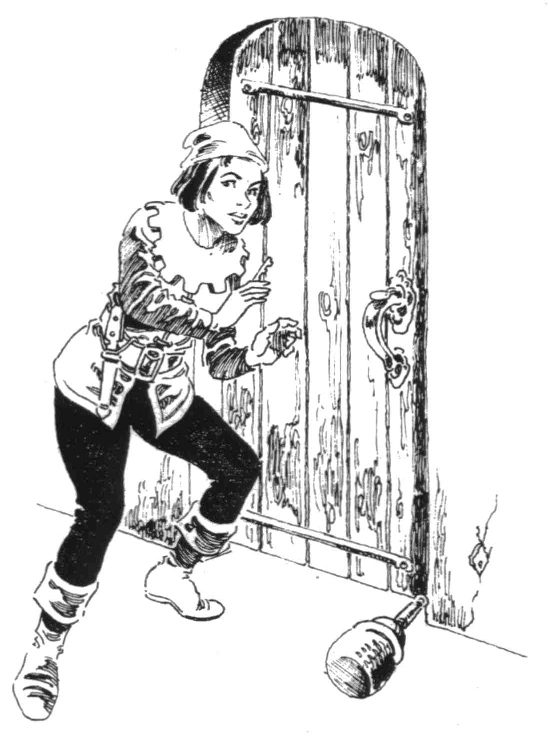

the roll is less than or equal to the success percentage, the spy or thief notices the location of the trap. lf the roll is above the success percentage, they remain blissfully unaware of the trap's presence.

For Spy to Detect Trap
([2 x Perception] + [7 x Rank] )

For Thief to Detect Trap
([Perception] + [11 x Rank] )

For Spy to Remove Trap
([MD] + [7 x Rank] - [5 x Trap Rank] )

For Thief to Remove Trap
([2 x MD] + [11 x Rank] - [5 x Trap Rank] )

MD = Manual Dexterity

When a spy or thief attempts to remove a trap, the GM rolls percentile dice. If the roll is less than or equal to the success percentage, the spy or thief has removed the trap without triggering it. lf the spy or thief has a trap container (see 61.9), he may store the removed trap. If the GM's roll is greater than the success percentage, the trap is triggered (see 57.2).

[61.4] A spy or thief can sometimes detect a secret or hidden aperture.
Any character can try to find a secret or hidden aperture if they spend time sounding and searching the appropriate wall, floor, or ceiling.

A spy or a thief has a ([2 x Perception] + [5 x Rank])% chance of noticing that a secret or hidden aperture is within (5 + Rank) feet of them.
If the GM's roll on percentile dice is equal to or less than the success percentage, the spy or thief character senses that at least one hidden or secret door is in their detection area (but is not told how many). If the roll is greater than the success percentage, the spy or thief does not notice the aperture(s).

[61.5] A spy or thief can attempt to pick the pocket of another being without being detected.
A spy or thief has a base success percentage equal to ([3 x Manual Dexterity] + [6 x Rank])% to pickpocket a being. The following modifiers are applied to the success percentage:

The victim is unconscious | +50%
The victim is sleeping or stunned | +25%
The victim cannot see well in current circumstances (e.g., human at night) | +10%
The victim is inebriated | +5%
The pickpocket attempt is made in an uncrowded area and the victim has at least a slight suspicion of the spy or thief's intentions | -15%
The object to be pickpocketed is in a sealed pocket, pouch or compartment | -20%
The object to be pickpocketed is affixed to the victim's person or is something used constantly during the day by the victim | -30%
The object makes noise when moved | -25%
The victim wears metal armor or garments | -5%
The victim is an assassin thief or spy: Subtract (5 x Victim's Rank)%

It is assumed that the spy or thief attempting to pickpocket is not handicapped by their physical condition; if they are, the GM should modify the success percentage accordingly.
If the GM's roll on percentile dice is equal to or less than the success percentage, the spy or thief filches the object desired without their victim noticing. If the roll is between one and two times the success percentage, the spy or thief is detected by the victim just after the object has been removed from its storage place. If the roll is equal to or greater than twice the success percentage, the spy or thief is caught with their hand in the victim's pocket.

[61.6] A spy or a thief will develop a photographic memory as they gain experience.
A spy's success percentage to employ their photographic memory ability is ([2 x Percep-tion] + [12 x Rank] )%. A thief's success percentage is ([Perception] + [10 x Rank] )%. A spy or thief can use the ability without error for up to (1 + [1 x Rank]) days. When a spy or thief

uses the ability after the error-free time limit is expired, reduce their Rank for success percentage calculation (only) by one for each day over that time limit.
If the GM's roll on percentile dice is equal to or less than the success percentage, the spy or thief can recall visual details, such as those of a room or a piece of parchment, etc. if they observed it for the requisite length of time. A spy must have observed the object in question for (120 - [10 x Rank]) seconds to use the ability, and the thief must have spent twice that time. If the roll is greater than the success percentage, the spy's or thief's memory has more and more gaps in it as the roll approaches 100.
A spy or thief tests their photographic memory ability whenever they try to verbally describe an object or place, whenever they call on their memory to gain a mental image of the object or place, or whenever they record it in writing. If a spy or thief fails to recall an object or place once, they cannot use the ability again to try to recall the image of that object or place unless they have sine returned to it.

[61.7] A spy increases their chance of performing an activity involving stealth (see 83.3) by 2% per Rank they have achieved; a thief increases their chance to perform stealth-related action by 1% per Rank.

[61.8] A spy or thief acquires an ability unique to their skill.
A spy may use their photographic memory ability to recall spoken phrases. Even if a spy does not know the language used, they can reproduce the phrases phonetically. Additio-nally, when a spy concentrates for (60 - [5 x Rank] ) seconds, they can extend their range of vision and hearing to (100 + [5 x Rank])% of what it normally is.
A thief can, as long as they can find a purchase sufficient to bear their weight, climb any structure. Their success chance when climbing on a structure not made for that purpose is ([4 x Manual Dexterity] + [10 x Rank] - [Structure Height in Feet /10] )%. Round the structure height down. If the GM's roll is greater than the success percentage, the thief has fallen in climbing the structure. To determine the height at which the thief falls, roll D100. Round the number off to the nearest 10% (a roll of 5 is rounded down), and multiply the height the thief sought to attain by that percentage. A thief suffers ([Height in Feet /10] Squared) Endurance Points when they fall.

[61.9] A spy or thief must spend (250 + [150 x Rank] ) Silver Pennies per year to maintain a proper set of thieving equipment.
A spy or thief who does not spend the above amount operates as if he were two Ranks less proficient when performing any of the abilities described in 61.2, 61.3, and 6l.5. If their Rank for these abilities is temporarily reduced to a negative number, they cannot perform them until they meet expenses.
DRAGONQUEST SECOND EDITION, PAGE 98

The above cost does not include any trap containers (see the Basic Goods Cost List, 84.4) that the spy or thief may wish to purchase

62. TROUBADOUR
In a DragonQuest world, a minstrel who wishes to be welcome for his entertainment abilities during his travels is known as a troubadour.
A troubadour becomes a multi-talented performer as he increases his experience in the field. The troubadour is also a student of the people he visits, and is as knowledgeable as a scholar in the matter of customs. A troubadour, being a skilled actor, can also be a master of disguise. The most useful ability a troubadour will gain is his bardic voice, which enables him to influence the actions of all but the deaf.
The abilities subsumed in the troubadour rules are usable by such a character in situations not explicitly covered in the next few pages. The GM should improvise and allow a trouba-dour character to use his skill in appropriate instances.

[62.1] A troubadour acquires one ability per Rank.
The character begins with one of the following abilities at Rank 0. All acquired abilities can be performed skillfully.

1. Play the instrument of the player's choice. The character must acquire this ability anew for each separate instrument he wishes to use.
2. Sing or chant.
3. Recite stories and legends.
4. Compose stories and legends.
5. Perform mime.
6. Mimic speech.
7. Act out skits or parody.
8. Tell and compose jokes.
9. Dance (especially folk dance).
10. Dress appropriately to all situations.
11. Simulate wide range of emotions.
12. Execute acrobatics.
13. Amuse small children.
14. Amuse semi-intelligent creatures.
15. Appear attractive.

A troubadour may gain additional abilities after achieving Rank 10 by the expenditure of 500 Experience Points per ability.

[62.2] A troubadour's chance of successfully performing minor magic (see 42.2) is increased by 2 per Rank.

[62.3] If a troubadour is a mage of the College of Illusions (see 223), they add 1 to their modified chance to cast a spell for every Rank they achieve.

[62.4] When a troubadour uses his Perception value to gain information (see 42.3) about the customs or habits of humanoids, add 2 per Rank he has achieved to his success percentage.

[62.5] A troubadour can use disguise to appear of a different humanoid race, gender, or profession.
A troubadour cannot disguise himself as a member of a race for which his size is inappropriate (e.g., an elf troubadour cannot disguise himself as a halfling) or as practitioner of a profession for which he is basically unsuited (e.g., a frost giant troubadour could not imitate a jockey). A troubadour's disguise ability is intended to fool someone who does not know the humanoid the troubadour is masquerading; if the troubadour is attempting to pass himself off as an acquaintance of a particular being, the GM will have to determine the chance of the substitution being noticed.
A troubadour's base success percentage to use this disguise ability is (12 x Rank)%. Subtract:
1. Two times the Perception of the being to be deceived by the troubadour if the troubadour is impersonating a member of his own race.
2. Four times the Perception of the being to be deceived by the troubadour if the troubadour is impersonating: a member of another race.
3. (11 - [Troubadour's Rank] ) if he impersonates a person of opposite gender.
If the GM's roll on percentile dice is equal to or less than the troubadour's success percentage, the being to whom the troubadour is falsely representing himself is taken in. If the roll is greater than the success percentage, the being notices inconsistencies (with the role being assumed) in the troubadour's appearance or behavior. The inconsistency becomes more glaring as the roll approaches 100.
If a troubadour is using disguise in close proximity to a being, a check against their success percentage must be made every hour.

[62.6] A troubadour can use their bardic voice to charm, several beings at once.
A troubadour may use his bardic voice on not more than (2 + [2 x Rank] ) beings who can understand the language which he speaks. The troubadour may not use the voice ability in combat, but may use it against hostile beings. A Willpower check must be made for every being the troubadour hopes to affect. The success percentage for the Willpower check is ([10 x Troubadour's Rank] -[2x Being's Willpower] )%. If the roll is less than or equal to the success percentage, the being is charmed, as described in the College of Ensorcelments and Enchantments spell of the same name (see 221). If the roll is greater than the success percentage, the being is not affected.
A troubadour must spend (15 - Rank) Fatigue Points every time he uses the bardic voice ability.

[62.7] A troubadour must spend (50 + [100 x Rank) Silver Pennies per year to supply himself with the props necessary for his trade.
A troubadour who does not spend the above amount operates as if they were two Rank less proficient. If the rank of a troubadour is reduced to a negative number, the use of the skill is temporarily lost.

VIII.
Monsters

The player characters represent only an infinitesimal fraction of the inhabitants of the DragonQuest world. The GM is responsible for playing the part of those inhabitants that the characters meet during their adventures. These inhabitants will be of roughly two types: non-player characters (NPC's) and monsters.
Non-player characters are those inhabitants who are of races or species from which a player character could also come or which are closely-related to those races. Monsters consist of those inhabitants who come from races or species from which a player character could not come. These two classes are further broken down into other categories depending upon the element in which the Players are most likely to encounter them and whether or not they are common or fantastical. Common monsters are those that dwell throughout the DragonQuest world (as interpreted by the GM) while fantast-
SKILLS, MONSTERS & ADVENTURES, PG 99
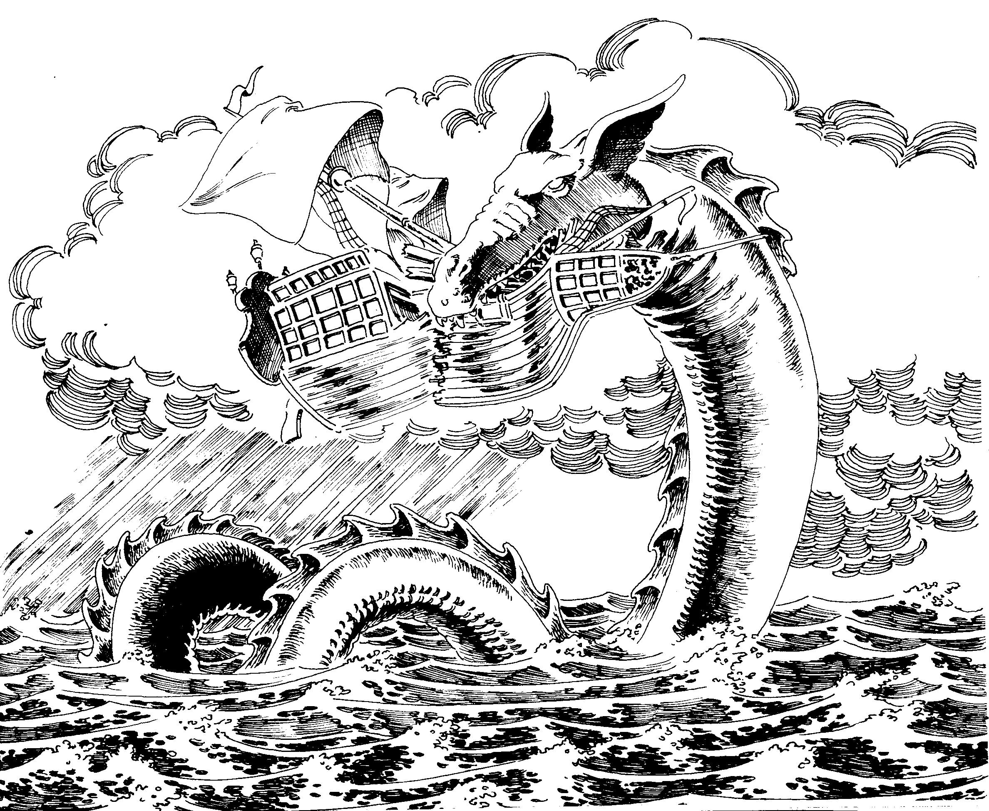

ical monsters are those rare species which are highly magical and will tend to be found only in isolated areas (especially areas that are mana-rich).
The GM pregenerates some monsters and NPC's prior to play so that they may be brought into play whenever the players' characters arrive at their destination or otherwise stumble on them. He need not keep detailed records on all monsters. Instead, he may write the most important information concerning a monster on a 3" x 5" index card, with a master list of all monsters kept on a single sheet. The GM may wish to save time and effort by using the same numbers for all NPC's/monsters of the same race or species found in the same place, possibly varied for one or two characteristics if additional flavor is desired. The GM creates these characters and monsters by choosing (or randomly generating) a number which falls within the parameters given for each type of character or monster under the monster descriptions in this Section.
Alternatively, the GM may wish to keep index cards for various monsters, and pull one at random whenever the characters are due to encounter an NPC/monster. The GM may wish to present his own monsters and NPC's to

characters whenever they randomly encounter wandering monsters or NPC's (those not placed in advance) or he may wish to use the mechanic provided in this rule section (see 63).

63. ENCOUNTERING
MONSTERS AND NON-
PLAYER CHARACTERS
The frequency with which players' characters will encounter monsters and NPC's will be determined by the GM. There are two types of encounters the players' characters may have: encounters with pre-positioned monsters and NPC's (usually in their lair or dwelling) and encounters with wandering monsters and NPC's in a more or less random pattern. The GM may choose to use his own system for determining when and how the latter are encountered or he may choose to use the following system:
The GM secretly chooses the "Danger Level" of the area through which the players are adventuring. This level determines how fre-quently the GM must check to see if the characters encounter a random (not previously emplaced) monster or NPC, the Base Chance of encountering anything (dependent in part on the terrain), and the number which is added to the

dice roll to determine the type of encounter the characters have. All of these factors are included on the Danger Table (63.1). If an encounter takes place, the GM then consults the
Encounter Table (63.2) to ascertain the exact nature of the monster or NPC encountered.
Whenever the Danger Table indicates that an Encounter Check must be made, the GM indexes the Danger Level of the area with the type of terrain that is predominant. The intersection of line and column on the Danger Table results in the Base Chance of there being an Encounter. The GM then rolls DI00, and if the result is less than or equal to the Base Chance of an encounter, an encounter occurs. The GM rolls DI00 and adds to the resulting number the modifier listed on the Encounter line of the Danger Table for the Danger Level of the area in which the encounter takes place. The result is indexed with the appropriate terrain type on the Encounter Table to find the name of the monster or NPC the players encounter. Beside the name of each monster/NPC is a number which the GM adds to the result of a D10 die roll. The modified die result is the number of monsters or NPC's of the appropriate type which the characters encounter (minimum ~ of 1). If the designation "Human" results, the GM must again roll D100 and add to the result the modifier given on the appropriate Encounter Line of the Danger Table. The resulting number is indexed with the Humans column on the Encounter Table to determine the class of humans the players encounter. Next to the class is a number which is added to the dice roll used to determine the initial reactions of the monsters or NPC's encountered (see 64). Note: Modified results of greater than 125 are treated as 125. Results less than 1 are treated as 1.
The GM may wish to vary slightly the regularity with which he makes Encounter Checks so as to keep the players from anticipating danger too easily.
[63.1] Danger Table
(see page 102)
[63.2] Encounter Table
(see page 101)

64. REACTIONS
TO ENCOUNTERS
Unless the GM has established a reaction for the NPC/monster the player characters have encountered, he consults the Reaction Table, rolling D100 and adding to or subtracting from the result whatever number he believes appropriate to the situation in addition to those modifiers listed on the Humans column of the Encounter Table, where appropriate. The GM determines the modifier before rolling the dice. It should seldom exceed 30. The GM may add negative numbers to the dice roll. The modified dice roll number indicates the reaction of the monster(s) or NPC(s) to the encounter as follows:

Dice Reaction
01-10 Enraged: Immediately attacks party.
DRAGONQUEST SECOND EDITION, PAGE 100

11-30 Belligerent: Immediately attacks unless somehow mollified.
21-30 Wary: Inclined to attack, but does not immediately charge.
31-40 Unfriendly: Willing to communicate on a limited basis, but will not cooperate and may attack if patience is tried too severely.
41-60 Neutral: Willing to communicate or to allow the party to pass by without hindrance. Has no positive or negative feelings about the party.
61-75 Pleasant: Willing to communicate, including in his conversation useful hints about the area, but still intent upon his own business.
76-85 Friendly: Willing to communicate and provide minor assistance (such as providing temporary lodging).
86-95 Charmed: Willing to assist the party in any way which does not imperil the NPC/ monster's own interests. He may even be talked into joining the party temporarily.
96-100 Enraptured: Willing to join the party immediately upon being asked. Will totally identify with the party and its interests even to his own peril.
The nature and degree of any modification will depend upon the race or species of the monster or NPC encountered, on the manner in which the characters habitually treat entities they encounter, and on such unpredictable details as whether the monster currently has its young in tow and is thus primarily concerned with their welfare. Once the initial reaction has been determined, the ensuing interaction of the characters with the monster or NPC will depend upon the actual interaction of the players and the GM, as modified by their respective perceptions of the prejudices, perceptions, and characteristics of their characters.
[64.1] The Physical Beauty of a Monster (or lack thereof) may cause characters to react in unpredictable ways.
Whenever characters encounter a monster whose Physical Beauty is less than 6, they must make a Willpower check of (4 x Will-power). If they roll above this result, they must then roll on the Fright Table (see 44.8), and apply any results before they take any other action. If affected they receive another Willpower check every second Pulse until they recover. Until that time, they will act as the result on the Fright Table indicates. Note: The relative Physical Beauty of monsters will in part determine character interaction with them and will also determine in part the interaction of a party of characters accompanied by such a monster with other randomly-encountered NPC's or monsters.

65. HOW TO READ THE
MONSTER DESCRIPTIONS
Sections 66 through 76 list the various types of fauna that may be encountered in the Dragon-Quest world. Each Section describes one type of fauna and provides detailed information on some specific representative examples of that type. These sample creatures are discussed in detail according to the format given above right.
Name: The name of the monster (or NPC type, hereafter called simply "monsters").

Natural Habitat: The environment(s) in which the monster is most likely to be found, including subclasses of the 10 basic terrain types discussed in 63.
Frequency of Appearance: There are 4 designations given under this heading, each representing the relative rarity of the monster as a guide to the GM in placing them in his world. In ascending order of rarity, they are: Common, Uncommon, Rare, Very Rare.
Number: The average number of specimens of the monster which will be found together in one place, usually expressed as a span of numbers. In some cases, this span will be followed by a single number which indicates that this is the number most frequently found together.
Description: A description of the monster as perceived by human senses.
Talents, Skills, and Magic: Includes a ist and description of all the talents possessed by the monster as well as any skills mastered and whether the monster possesses any magical talents or is an Adept of a College of magic.
Movement Rates: A list of the Flying, Swimming, Running, Climbing, Crawling, and Tunneling speeds of the monster. These are given in yards (usually hundreds) per minute. These numbers are used primarily in the Adventure Sequence for purposes of establishing chase speeds. The Movement Rate of humanoids is Running: 250.
PS: Physical Strength. MD: Manual Dexterity. AG: Agility. MA: Magical Aptitude. EN: Endurance. FT: Fatigue. WP: Will-power. PC: Perception. PB: Physical Beauty. TMR: Tactical Movement Rate. TMR's are listed in the same order as they are listed in Movement Rates. A monster's TMR is equal to its Movement Rate divided by 50. These characteristics function in the same manner as the characteristics of player characters except for Physical Beauty, which measures the relative emotional response (in ascending order of approval from 1) of player characters to the physical appearance of the monster (but not NPC). These characteristics are given as a span of number in most cases. The GM may choose to pick a number from the span or he may randomly generate a modifier to the lowest number in the span (which serves as a base).
NA: The monster's Natural Armor, given as the number of Damage Points (DP's) absorbed by the monster's skin, scales, etc., for each Strike.
Weapons: The natural weapons of the monster in the forms of claws, teeth, talons, etc. The damage done by each natural weapon, its Base Chance and, in some cases, its possible Rank, are listed along with each weapon. Monsters always add their Manual Dexterity to their Base Chance with any natural weapon whether Ranked or not. For purposes of Grievous Injury, all teeth, horns, and tusks do type A damage. Talons and claws do type B damage. Hooves and other appendages to butt or kick do type C damage.
Comments: Any special characteristics of the monster, including its preferences in diet, treasure that it may have scavenged, etc., are discussed under this heading.

Dice
Roll
See next page for Notes.

DRAGONQUEST SECOND EDITION, PAGE 102

ENCOUNTER TABLE (continued)
KEY: The names in each terrain column are those of the species the characters encounter when the dice roll for that species occurs. The Humans column of the Encounter Table gives the class of the humans (or humanoids) encountered followed by a number, which is added to the initial Reaction Check (see 64). Human classes include the following: Resident: The indigenous inhabitants of the area, including local tradesmen, farmers, nobles, witches, warlocks, village idiots, constables, etc. Except in extremely dangerous areas, the locals are likely to be friendly (or at least neutral) and to be generally mundane (few heroes or great mages will be found among them). There will be exceptions to this rule, especially when the players stumble on isolated cots in the woods occupied by elderly women who keep cats. Substitute merchant for resident if at sea. Merchant: Those traders who travel long distances between trading centers, making high profits as a result of their willingness to risk venturing through wild areas to ply their wares. Merchants will almost always be accompanied by slaves and armed body guards. They will generally carry [D + 5] x 3,000 Silver Pennies worth of treasure or trade goods. Large parties (10 or more) will usually include an Adept and/or heroic fighter (a fighter with exceptional characteristics and Rank with weapons) hired by the merchant for protection. If encountered at sea, the value of any treasure or trade goods will be tripled and at least two thirds of the party will be armed soldiers with slaves and sailors making up the balance. Sea-going merchants will always have at least one (and possibly two or three) Adepts on board ship. Soldier: This class includes everything from individual messengers of the local potentate through medium-sized companies of condottieri. Soldier bands will include one heroic fighter for every 10 soldiers and one Adept and one military scientist in every band of 20 or more. Soldiers will usually be heavily armored (chainmail at the least) and armed and will often possess booty worth [D-2] x 100 Silver Pennies. per man. If at sea, double the value of treasure carried. Soldiers encountered in military vessels at sea will always be accompanied by at least one (and sometimes more) military scientists and Adepts. Brigands: This class encompasses thieves, highwaymen, cutpurses, pirates, and other unsavory types indigenous to the area. They will usually be lightly armed and will seldom include in their ranks adepts or military scientists, though heroic fighters will usually be present. Brigands will usually carry [D - 3] x 100 Silver Pennies worth of coins and jewelry in addition to the value of their weapons (which are often bejeweled). Seaborne brigands will have twice the treasure of their land faring brethren. Usually, brigands will be content to steal all of the worldly possessions of their victims and then allow them to depart with their lives. Seagoing brigands may, however, impress one or more of their victims as galley slaves and will sometimes amuse themselves by keelhauling the remainder of the party or otherwise killing them all. Reavers: Reavers are much like brigands except that they are not indigenous to the area and tend to enjoy slaughter almost as much as looting. Reavers will always be accompanied by 1 heroic fighter for every 8 men and 1 military scientist per 15 men. Each party will have one (and only one) Adept along (usually one versed in the Elemental Colleges). They will always be mounted if encountered on land. They will possess the same treasure and weapons as brigands, but will be more heavily armored (chainmail or leather in addition to a cloth armor undergarment). Reavers always kill their victims, usually by torture. If they haven't the time to torture their victims on the spot, they will carry them off and torture them later. Seagoing reavers will lock any of their victims they do not make into galley slaves in the hold of the victims' ship, which they will then set afire. Adventurer: This class includes characters similar to those of the players, themselves. Adventurers will usually be in the company of one or more non-humans or monsters. They will always be heavily armed and armored, will inevitably include one or more Adepts in their company and will possess [D + 5] x 300 Silver Pennies each on the average. Pilgrims: All monks, holy men, wandering hermits and the like are included in this class along with religious pilgrims bound for one or another shrine. They will generally be lightly armed, wear little or no armor and include no heroic fighters or military scientists. They may number an Adept or two (usually of little note) among their company. Except for hermits, they will possess [D + 3] x 100 Silver Pennies each on the average. They will usually mind their own business, attacking only out of fear and may sometimes be robbed without a fight. If a holy man or monk is part of the company, he may secretly lay a curse on the players' characters if they do the pilgrims harm.

[63.1] DANGER TABLE
DANGER
LEVEL Low Small Moderate High Extreme
Frequency 168 72 24 6 2
Cavern - 10% 20% 30% 45%
Crypt* 2% 17% 27% 37% 52%
Field 25% 40% 50% 60% 75%
Marsh 5% 15% 30% 40% 55%
Plain - 10% 20% 30% 40%
Ocean - 10% 25% 35% 55%
Rough - 3% 13% 25% 40%
Ruin - 10% 25% 35% 50%
Waste - 5% 15% 25% 40%
Woods - 15% 25% 40% 50%
Encounter - 25 - 10 + 5 + 10 + 25

Danger Level: The relative chance of an encounter with potentially hostile NPC's or monsters, given in five increments in ascending order of danger from Low to Extreme. Frequency: The frequency (in hours) with which the GM must make an Encounter Check depending upon the Danger Level of the area occupied by the characters. Cavern, Crypt, etc.: The 10 major terrain types in which the characters may adventure. The percentage found by indexing the terrain type with the Danger Level is the Base Chance of any encounter (of any type) occurring when the characters are in that type of terrain. Cavern includes all caves, tunnels, natural caverns, and other underground areas which are not part of an inhabited dwelling. Crypt includes all barrows, crypts, burial mounds, graveyards, and other places of internment for the dead. Field includes cultivated fields, vineyards, moors, heaths, etc. (usually near inhabited areas). Marsh includes all swamps, metes, ponds, etc. In addition, small streams and rivers are included herein, but 10 is subtracted from the Base Chance if checking for an encounter as a result of a stream or river crossing when other terrain of this type is not present. Plain refers to all plains, steppes, and other more or less open and flat or rolling terrain. Ocean includes oceans, seas, and large lakes. If the adventurers are on a lake, the Base Chance for this type of terrain in reduced by 10. Rough refers to both hills and mountains, but 20 is added to the Base Chance if the characters are in mountains instead of hills. Ruin includes all abandoned dwellings (cities, castles, monasteries, villages, etc.). Waste includes all deserts, wastelands, salt flats, etc., where life is not likely to be found in profusion. Woods refers to all wooded glens, forests, brush land, etc., where large amounts of common wildlife are likely to be found and where few humanoids dwell. If the area is deep forest, add 10 to the Base Chance of an encounter. Encounter: The number added to the dice roll on the Encounter Table which is used to determine exactly what type of NPC or monster is encountered. #%: The Base Chance of an encounter in the terrain type the adventurers occupy at the current Danger Level. (-): No chance of an encounter occurring in this type of terrain at this Danger Level. Note: Inhabited dwellings, cities, towns, etc., have not been included on this table, since the GM will almost always prefer to inhabit these areas with monsters/NPC's of his own choice.

